Contribution Title

Doctoral Symposium (Title Style, Font Size 16pt)

  - First Author^{1,*} and Second Author^{1,2}
¹Department, Institution, City, Country, https://orcid.org/0000-1111-2222-3333
²Department, Institution, City, Country, https://orcid.org/0000-1111-2222-3333

*Corresponding author: corresponding@eccf.ukim.edu.mk
PhD Program: Program
PhD Institution: Institution
Number of months devoted to the work: Number

Abstract. The abstract serves both as a general introduction to the topic and as a brief, non-technical summary of the main results and their implications. The abstract must not contain abbreviations, equations, headings, or subheadings. The word limit is 150-200 words. (Abstract body text)

Keywords: First keyword, Second keyword, Third keyword. (list up to five keywords)
JEL Classification: C32, E31, E52. (list up to three JEL Classification codes)

- INTRODUCTION
In the Introduction, authors should clearly establish the study’s context and relevance by outlining the problem addressed and its importance to the field. The section should provide a concise review of the most pertinent literature to position the work within existing knowledge, identify the specific gap or unresolved issue the manuscript addresses, and state the study’s aims and research questions and, where appropriate, clear structuring of hypotheses. The Introduction should also briefly indicate the manuscript’s contribution and originality and may conclude with a short overview of the paper’s structure. (Body style)
Doctoral symposium papers are restricted to 6 pages, including appendices and references. A typical Doctoral symposium paper will consist of approximately 2,000-3,000 words. First Author placeholder is reserved for the PhD student, while the Second Author placeholder is reserved for the mentor. (Body style)

theoretical background
When referencing literature in-text, use the APA 7th Edition style of referencing detailed in the References section. Mind the rules when referencing a single author (Akerlof, 1970), two authors (Black & Scholes, 1973), or three or more authors (Aizenman et al., 2004).
The following bibliography provides a sample reference list with entries for journal articles (Kwiatkowski et al., 1992), a book (O’Harrow, 2006), a working paper (Aizenman et al., 2004), proceedings paper (Jakkilinki et al., 2007), a newspaper article (Elliott, 2024, Sir Nicholas Winton, 2026}, a homepage (“World Bank Open Data”, n.d.), and a dataset (Campbell & Kahn, 1984). Multiple citations are grouped (Aizenman et al., 2004, Campbell & Kahn, 1984, Malkiel & Fama, 1970). (Body style)

methodology
Lorem ipsum dolor sit amet, nec timeam docendi placerat ea, amet sententiae theophrastus ex vis, quodsi laoreet civibus eos ex.
Lorem ipsum dolor sit amet, nec timeam docendi placerat ea, amet sententiae theophrastus ex vis, quodsi laoreet civibus eos ex. (Body style)

A Subsection Sample
Please note that the first paragraph of a section or subsection is not indented. The first paragraph that follows a table, figure, equation etc. does not need an indent, either.
Subsequent paragraphs, however, are indented. Use subheadings when having at least three subsections to introduce in your paper. (Body style)

A Subsection Sample
Lorem ipsum dolor sit amet, nec timeam docendi placerat ea, amet sententiae theophrastus ex vis, quodsi laoreet civibus eos ex. (Body style)

A Subsection Sample
For tables use the Insert Table option in Microsoft Word. Do not use pictures instead of tables. The first row should have the headings written in bold font. Avoid using vertical lines unless necessary. (Body style)
Table 1. Table captions should be placed above tables.
Variable name | Heading | Heading | Heading
A | 1,235 | 15.55 | Factor SD
B | 16 | 16.01 | Example 2
C | 10,457.12 | 17.32 | Variable name
D | - | - | Unknown
Notes: Lorem ipsum dolor sit.
Source: Lorem ipsum dolor sit.

Generally, if a quote exceeds 40 words or 4 lines, it should be formatted as a block quote (indented, no quotation marks). See the following example below.
Lorem ipsum dolor sit amet, nec timeam docendi placerat ea, amet sententiae theophrastus ex vis, quodsi laoreet civibus eos ex. Has ad omnis tempor persequeris, at vim vidisse volumus disputationi, ex nec soleat voluptatibus. Qui dicant vulputate elaboraret ad. Et vix menandri argumentum. Lorem ipsum dolor sit amet, nec timeam docendi placerat ea, amet sententiae theophrastus ex vis, quodsi laoreet civibus eos ex. (Respondent, R_01) (Quote style)
However, if a short quote is considered, it should appear in-text in quotation marks. For instance, the authors should consider inserting the following formatting for short quotes “Lorem ipsum dolor sit” (Respondent, R_01).
Although we encourage authors to send us the highest-quality figures possible, for peer-review purposes we can accept a wide variety of formats, sizes, and resolutions. Legends should be concise but comprehensive - the figure and its legend must be understandable without reference to the text. Include definitions of any symbols used and define/explain all abbreviations and units of measurement.

Sample Heading (Third level) (Heading 3 style) Only two levels of headings should be numbered. Lower level headings remain unnumbered; they are formatted as run-in headings. (Body style)

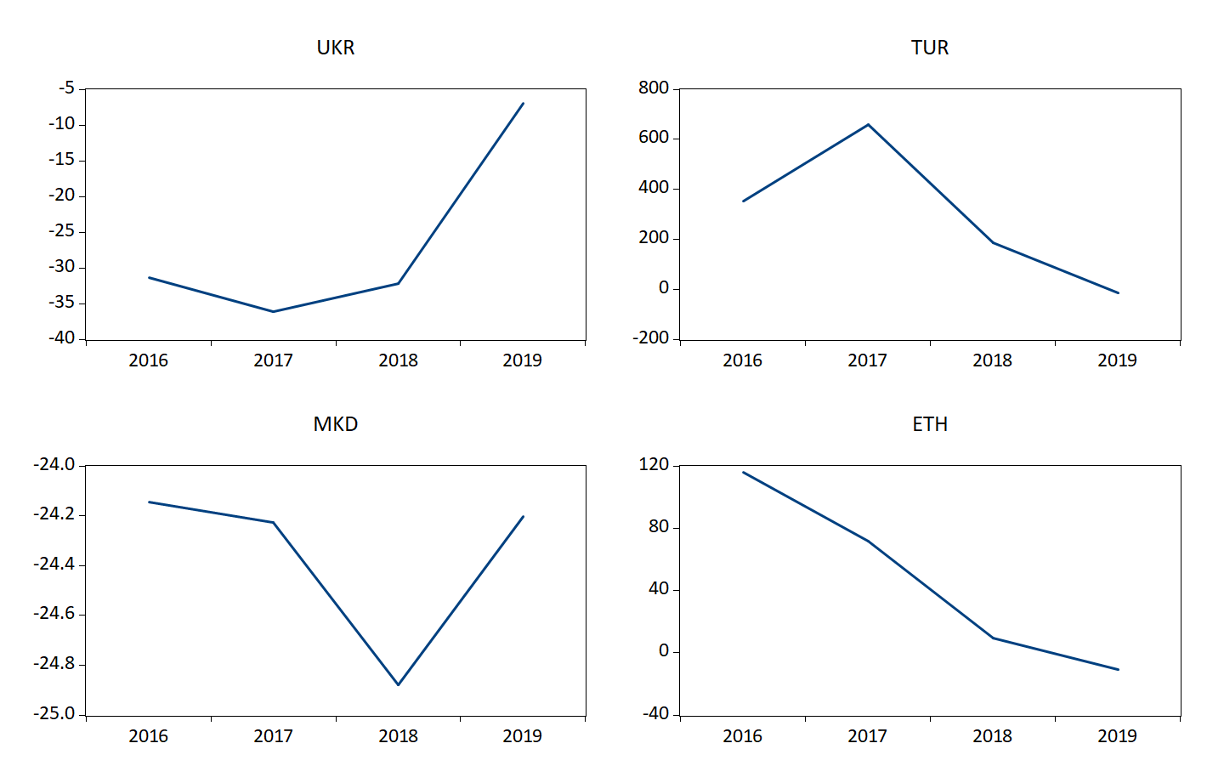
Figure 1. A figure caption is always placed below the illustration.

This is a numbered equation
$$\begin{aligned}\int_{0}^{2}{x^{2}e^{2x}dx}\#\left(1\right)\end{aligned}$$
For equations, use the Equation Editor. To numerate equations, at the end of the equation write #(1) for example, and press Enter. Within text, use the Insert Equation option to denote mathematical notation, such as $α$, $Δ$, or $ω$. Do not use text symbols. Do not numerate equations in proofs.

results
Lorem ipsum dolor sit amet, nec timeam docendi placerat ea, amet sententiae theophrastus ex vis, quodsi laoreet civibus eos ex. (Body style)

discussion
Lorem ipsum dolor sit amet, nec timeam docendi placerat ea, amet sententiae theophrastus ex vis, quodsi laoreet civibus eos ex. (Body style)

conclusion
Lorem ipsum dolor sit amet, nec timeam docendi placerat ea, amet sententiae theophrastus ex vis, quodsi laoreet civibus eos ex. (Body style)

Acknowledgments (Heading 3 style) Acknowledgments are not compulsory. Where included they should be brief. Grant or contribution numbers may be acknowledged. Please place your acknowledgments at the end of the paper, preceded by an unnumbered run-in heading (i.e. 3rd-level heading). (Body style)

Funding (Heading 3 style) Include this section in your manuscript to ensure full transparency about financial support. Authors must state all sources of funding that supported the research and/or the preparation of the manuscript (e.g., grants, institutional funding, scholarships, research contracts), including the funder name, grant/award number (if applicable), and the recipient(s) of the award. If the funder had any involvement in the study, authors should clearly describe the funder’s role, such as study design, data collection, analysis, interpretation, writing, or the decision to submit. If no external funding was received, delete this section. (Body style)

Conflict of Interest (Heading 3 style) Authors must include a Conflict of Interest (COI) Disclosure statement at the end of the manuscript to ensure transparency and protect the integrity of the review process. A conflict of interest exists when authors have financial, professional, or personal relationships that could be perceived to influence the research. All authors are required to declare any actual or potential conflicts, and where relevant, describe the nature of the relationship and the entity involved. If no conflicts exist, include the statement: “The author(s) declare no conflict of interest.” (Body style)

references
References to other publications must be in APA 7th Edition style and carefully checked for completeness, accuracy and consistency. A reference list in alphabetical order should be provided at the end of the paper. Details and examples are presented below.

Journal article (1 author) | Surname, Initials. (Year). Title of article. Journal Title, Volume(Issue), xx–xx. https://doi.org/xxxxx  e.g., Akerlof, G. A. (1970). The market for “lemons”: Quality uncertainty and the market mechanism. The Quarterly Journal of Economics, 84(3), 488–500. https://doi.org/10.2307/1879431
Journal article (2 authors) | Surname, Initials., & Surname, Initials. (Year). Title of article. Journal Title, Volume(Issue), xx–xx. https://doi.org/xxxxx  e.g., Black, F., & Scholes, M. (1973). The pricing of options and corporate liabilities. Journal of Political Economy, 81(3), 637–654. https://doi.org/10.1086/260062
Journal article (3+ authors) | Surname, Initials., Surname, Initials., Surname, Initials., & Surname, Initials. (Year). Title of article. Journal Title, Volume(Issue), xx–xx. https://doi.org/xxxxx  e.g., Kwiatkowski, D., Phillips, P. C. B., Schmidt, P., & Shin, Y. (1992). Testing the null hypothesis of stationarity against the alternative of a unit root. Journal of Econometrics, 54(1–3), 159–178. https://doi.org/10.1016/0304-4076(92)90104-Y
Working paper / report | Surname, Initials., & Surname, Initials. (Year). Title of report (Report/Working Paper No. xxx). Publisher/Institution. URL/DOI  e.g., Aizenman, J., Lee, Y., & Rhee, Y. (2004). International reserves management and capital mobility in a volatile world: Policy considerations and a case study of Korea (Working Paper No. 10534). National Bureau of Economic Research. https://doi.org/10.3386/w10534
Book | Surname, Initials. (Year). Title of book. Publisher.  e.g., O’Harrow, R. (2006). No place to hide. Free Press.
Proceedings (chapter in proceedings) | Surname, Initials., Surname, Initials., & Surname, Initials. (Year). Title of chapter. In Initials. Surname & Initials. Surname (Eds.), Title of book (pp. xx–xx). Publisher. https://doi.org/xxxxx  e.g., Jakkilinki, R., Georgievski, M., & Sharda, N. (2007). Connecting destinations with an ontology-based e-tourism planner. In M. Sigala, L. Mich, & J. Murphy (Eds.), Information and communication technologies in tourism 2007 (pp. 21–32). Springer. https://doi.org/10.1007/978-3-211-69566-1_3
Dataset | Surname, Initials., & Surname, Initials. (Year). Title of dataset (Version) [Data set]. Repository. https://doi.org/xxxxx  e.g., Campbell, A., & Kahn, R. L. (1984). ANES 1948 time series study (Version 3) [Data set]. ICPSR. https://doi.org/10.3886/ICPSR07218.v3
Newspaper / news website article (authored, online) | Surname, Initials. (Year, Month Day). Title of article. Newspaper Name. URL  e.g., Elliott, L. (2024, January 21). Globalisation is not dead, but it is fading: ‘Glocalisation’ is becoming the new mantra. The Guardian. https://www.theguardian.com/business/2024/jan/21/globalisation-glocalisation-industrial-policy-green-growth
Website / web page (group author, changing content with retrieval date) | Organization. (n.d.). Title of page. Retrieved Month Day, Year, from URL  e.g., World Bank. (n.d.). World Bank open data. Retrieved February 27, 2026, from https://data.worldbank.org

Aizenman, J., Lee, Y., & Rhee, Y. (2004). International reserves management and capital mobility in a volatile world: Policy considerations and a case study of Korea. National Bureau of Economic Research Working Paper Series. https://doi.org/10.3386/w10534
Akerlof, G. A. (1970). The market for “lemons”: Quality uncertainty and the market mechanism. The Quarterly Journal of Economics, 84(3), 488–500. https://doi.org/10.2307/1879431
Black, F., & Scholes, M. (1973). The pricing of options and corporate liabilities. Journal of Political Economy, 81(3), 637–654. https://doi.org/10.1086/260062
Campbell, A., & Kahn, R. L. (1984). ANES 1948 time series study (Version 3) [Data set]. ICPSR. https://doi.org/10.3886/ICPSR07218.v3
Capizzi, M. T., & Ferguson, R. (2005). Loyalty trends for the twenty-first century. Journal of Consumer Marketing, 22(2), 72–80. https://doi.org/10.1108/07363760510589235
Elliott, L. (2024, January 21). Globalisation is not dead, but it is fading: ‘Glocalisation’ is becoming the new mantra. The Guardian. https://www.theguardian.com/business/2024/jan/21/globalisation-glocalisation-industrial-policy-green-growth
Engle, R. F., & Granger, C. W. J. (1987). Co-integration and error correction: Representation, estimation, and testing. Econometrica, 55(2), 251–276. https://doi.org/10.2307/1913236
Jakkilinki, R., Georgievski, M., & Sharda, N. (2007). Connecting destinations with an ontology-based e-tourism planner. In M. Sigala, L. Mich, & J. Murphy (Eds.), Information and communication technologies in tourism 2007 (pp. 21–32). Springer. https://doi.org/10.1007/978-3-211-69566-1_3
Kwiatkowski, D., Phillips, P. C. B., Schmidt, P., & Shin, Y. (1992). Testing the null hypothesis of stationarity against the alternative of a unit root. Journal of Econometrics, 54(1–3), 159–178. https://doi.org/10.1016/0304-4076(92)90104-Y
Malkiel, B. G., & Fama, E. F. (1970). Efficient capital markets: A review of theory and empirical work. The Journal of Finance, 25(2), 383–417. https://doi.org/10.1111/j.1540-6261.1970.tb00518.x
O’Harrow, R. (2006). No place to hide. Free Press.
Winton, N. (2026, February 26). Corrections and clarifications. The Guardian. https://www.theguardian.com/news/2026/feb/26/corrections-and-clarifications
World Bank. (n.d.). World Bank open data. Retrieved February 27, 2026, from https://data.worldbank.org

APPENDIX

- Title of Appendix A

